**Men’s Health Week**

**June 10th-15th, 2019**

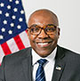

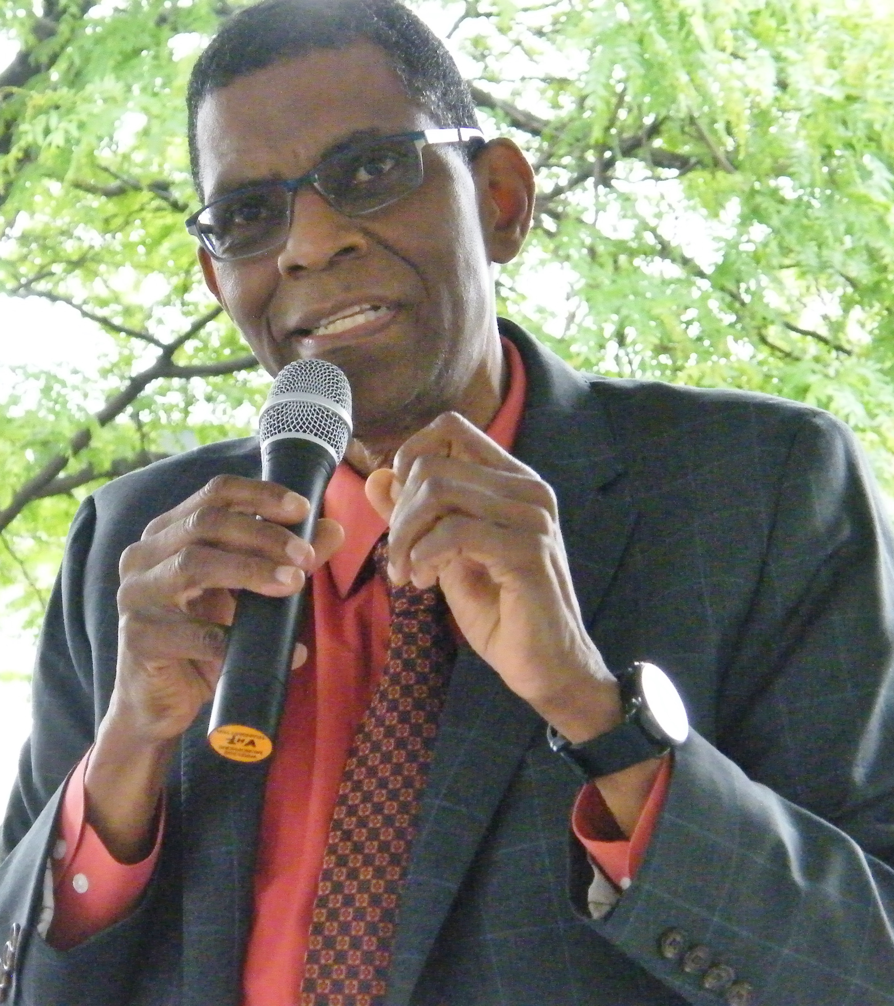

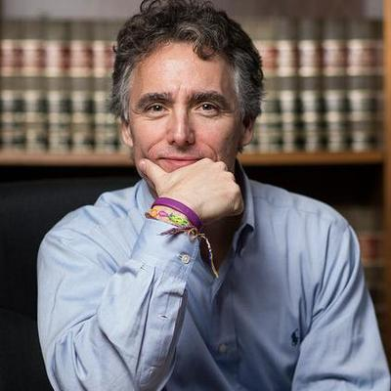

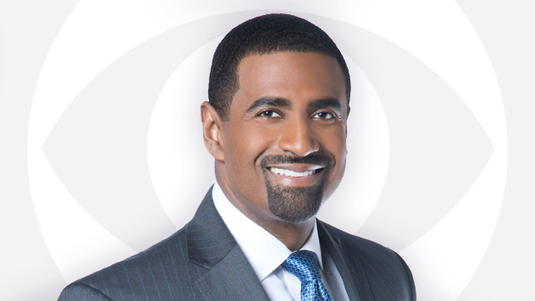

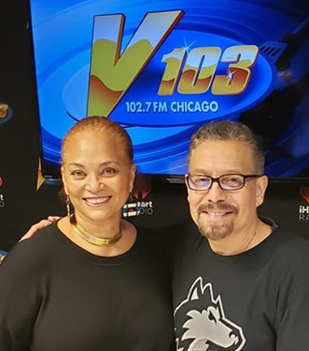



® May 2019

**SPONSORS:** Northwestern Medicine |

University of Chicago Medicine | LabCorp | Blue Cross Blue Shield of Illinois | Molina Healthcare of Illinois | Rogers Auto Group | Luster Products | Natural Awakenings | Rotary of Chicago O’Hare

**COMPLIMENTARY FOOD DEMOS | HAIR CUTS | INTERACTIVE WORKSHOPS | REFRESHMENTS | GIVE-A-WAYS**

**FROM 9 A.M. ­- 4 P.M. JUNE 10-14: FROM 9 A.M. - 1 P.M. JUNE 15:**

**Komed Holman Health Center Sunnyside Health Center Komed Holman Health Center**

4259 S. Berkeley Avenue 4501 N. Sheridan Road 4259 S. Berkeley Avenue

**Cottage View Health Center North Kostner Health Center Winfield Moody Health Center**

4829 S. Cottage Grove Avenue 1520 N. Kostner Avenue 1276 N. Clybourn Avenue

**Reavis School-Based Health Center Louise Landau Health Center**

834 E. 50th Street 800 N. Kedzie Avenue

**Winfield Moody Health Center Denny Community Health Center**

1276 N. Clybourn Avenue 30 W. Chicago Avenue

**FREE!!** Health Screenings **FREE!!**

Diabetes | Cholesterol | Hypertension | Colon Cancer | HIV Testing

**DR. TERRY MASON ATTY. GEN. KWAME RAOUL DERRICK YOUNG COOK COUNTY SHERIFF TOM DART JOE SOTO**

**KICKOFF EVENT SPEAKERS | JUNE 10TH, 2019 | 10 A.M. | 4259 S. BERKELEY AVE.**